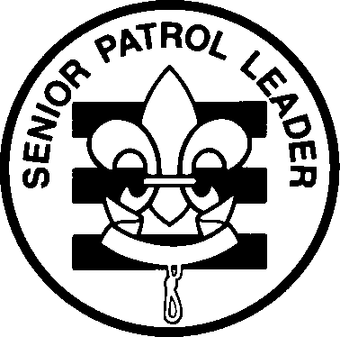
Troop 161’s Leadership Card
Senior Patrol Leader
Name: __________________________
Patrol: __________________________

Term: ___/___/____ to __/__/____

Job Description: The Senior Patrol Leader is elected by the scouts to represent them as a top junior leader in the troop.

Term Limits: A maximum of two consecutive six month terms.

Filled: Selected by the Scoutmaster.

Prerequisites: 1. A Scout must be of Life or Eagle rank.
2. A Scout must have served a complete six month term as Patrol Leader prior to assuming SPL.

Leadership Position Coordinator: Scoutmaster

Duties of Senior Patrol Leader:
1. Runs all troop meetings, events, and the annual program planning meeting + is in charge of all openings & closings
2. Chairs & runs the patrol leaders’ council meetings
3. He plans the Troop Meeting agendas
3. Appoints other troop junior leaders with advice and consent of the Scoutmaster & Assistant Scoutmasters
4. Assigns duties and responsibilities to junior leaders
5. Assists the Scoutmaster with junior leader training
6. Establishes campout duty roster and ensures execution of duties
7. Sets a good example
8. Wears the Scout uniform correctly
9. Lives by the Scout Oath and Law
10. Shows and helps develop Scout Spirit
11. Actively participates in outdoor activities

As Senior Patrol Leader, accept responsibility for these duties. __________________
(sign and date)

As Parent of the Senior Patrol Leader, I agree with the commitment my son is making and promise to support him in his duties (training, troop meetings). _________________________
(sign and date)

As Scoutmaster, I will assist you in carrying out your duties. ___________________
(sign and date)

-------------------------------------------------------------------------------------------------------------------------------------------------------------
Senior Patrol Leader Evaluation (at end of Term):

Scoutmaster ______________________

Date/Initials
_________ Briefed on duties and responsibilities
_________ Coordinate Patrols for flag ceremonies
_________ Establishes campout duty roster (wash stations, flag ceremonies, fire charts etc.)
_________ Plans the troop meeting agendas and oversees Troop meetings
_________ Is attired in Class A uniform at troop meetings
_________ Attend/lead 75% of troop meetings Actual percentage _____
_________ Attend/lead 55% of troop outings Actual percentage _____
_________ Attend/lead 75% of patrol leader council (PLC) meetings Actual percentage _____

Retain this form on file for the Advancement Coordinator
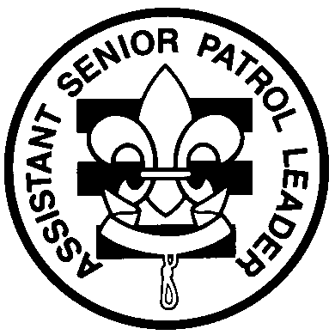
Troop 161’s Leadership Card
Assistant Senior Patrol Leader
Name: __________________________
Patrol: __________________________

Term: ___/___/____ to __/__/____

Job Description: The Assistant Senior Patrol Leader is the second-highest-ranking junior leader in the troop.
The assistant senior patrol leader is elected with the senior patrol leader by the troop. The assistant senior patrol leader acts as the senior patrol leader in the absence of the senior patrol leader or whenever called upon. He also provides leadership to other junior leaders in the troop. Large troops may have more than one ASPL.

Term limits: A maximum of two nonconsecutive six month terms.

Filled: Appointed by the Senior Patrol Leader with the advice and consent of the Scoutmaster.

Prerequisites: 1. A Scout must have served a complete six month term as an APL or PL prior to assuming ASPL.
2. A Scout must be the rank of Life or Eagle.

Leadership Position Coordinator: The Senior Patrol Leader

Duties of Assistant Senior Patrol Leader:
1. Helps senior patrol leader lead meetings and activities
2. Runs the troop in the absence of the senior patrol leader
3. Helps train and supervise the troop scribe, quartermasters, instructors, librarian, historian, chaplain aides & the O.A. representative
4. Serves as a member of the patrol leaders’ council
5. Sets a good example
6. Wears the Scout uniform correctly
7. Lives by the Scout Oath and Law
8. Shows and helps develop Scout Spirit
9. Actively participates in outdoor activities

As Assistant Senior Patrol Leader, I ____________________ accept responsibility for these duties.
(sign and date)

As Parent of the Assistant Senior Patrol Leader, I agree with the commitment my son is making and promise to support him in his duties (training, troop meetings). _________________________
(sign and date)

As Assistant Scoutmaster, I _____________________ will assist you in carrying out your duties.
(sign and date)

-------------------------------------------------------------------------------------------------------------------------------------------------------------
Assistant Senior Patrol Leader Evaluation (at end of term):

Assistant Scoutmaster ______________________

Date/Initials
__________ Briefed on duties and responsibilities
__________ Leads training of at least one troop position
__________ Ensures compliance with campout duty roster
__________ Assists Senior Patrol Leader on all troop outings and activities
__________ Submits a written monthly report on the non-elected officers (see #3) at each PLC
__________ Attend 75% of troop meetings Actual percentage _____
__________ Attend 55% of troop outings Actual percentage _____
__________ Attend 75% of patrol leader council (PLC) meetings Actual percentage _____

Retain this form on file for the Advancement Coordinator
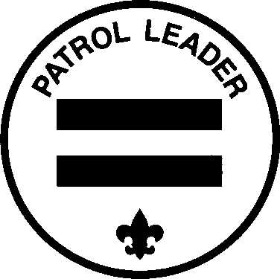
Troop 161’s Leadership Card
Patrol Leader
Name: __________________________
Patrol: __________________________

Term: ___/___/____ to __/__/____

Job Description: The Patrol Leader is the leader of his patrol. He represents his patrol in the patrol leaders’ council.

Term Limits: A maximum of two nonconsecutive six month terms.

Filled: Elected by his troop patrol.

Prerequisites: 1. A Scout must be of at least First Class rank.
2. Recommended that a Scout be APL prior to assuming PL.

Leadership Position Coordinator: Assistant Scoutmaster of that specific patrol

Duties of a Patrol Leader:
1. Appoints his assistant patrol leader
2. Represents the patrol in the patrol leaders’ council and all activities, meetings & outings
3. Plans, steers & controls his patrol
4. Helps each Scout in his patrol set an advancement goal & then helps him succeed (as helped set by his ASM)
5. Promotes patrol moral by showing the patrol flag & leading the patrol yell
6. Keeps all patrol members informed
7. Knows what his patrol members and other leaders can do
8. Prepares his patrol to take part in all troop activities & makes sure his patrol is represented in each
9. Responsible for attendance in each meeting or activity; which is then submitted to the Scribe
10. Responsible for all head counts no later than one week prior to the event unless specified earlier.
11. Sets a good example
12. Wears the Scout uniform correctly
13. Lives by the Scout Oath and Law
14. Shows and helps develop Scout Spirit
15. Actively participates in outdoor activities

As Patrol Leader, I ____________________ accept responsibility for these duties.
(sign and date)

As Parent of the Assistant Patrol Leader, I agree with the commitment my son is making and promise to support him in his duties (training, troop meetings). _________________________
(sign and date)

As Assistant Scoutmaster, I _____________________ will assist you in carrying out your duties.
(sign and date)

-------------------------------------------------------------------------------------------------------------------------------------------------------------
Patrol Leader Evaluation (at end of term):

Assistant Scoutmaster ______________________

Date/Initials
__________ Briefed on duties and responsibilities
__________ Lead the patrol in at least one opening or closing flag ceremony
__________ Complete and post duty roster for each campout (verified at campout)
__________ Present a written monthly report on his patrol activities at the Patrol Leaders Council
__________ Attend 75% of troop meetings Actual percentage _____
__________ Attend 55% of troop outings Actual percentage _____
__________ Attend 75% of patrol leader council (PLC) meetings Actual percentage _____

Retain this form on file for the Advancement Coordinator
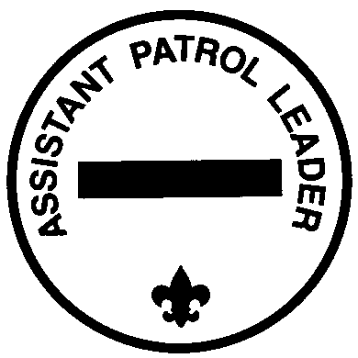
Troop 161’s Leadership Card
Assistant Patrol Leader
Name: __________________________
Patrol: __________________________

Term: ___/___/____ to __/__/____

Job Description: The Assistant Patrol Leader helps the Patrol Leader manage and organize his patrol

Term Limits: A maximum of two nonconsecutive six month terms.

Filled: Appointed by his Patrol Leader.

Prerequisites: A Scout must be of at least First Class rank.

NOTE: THIS POSITION DOES NOT COUNT FOR RANK ADVANCEMENT.

Leadership Position Coordinator: Assistant Scoutmaster for that specific patrol

Duties of an Assistant Patrol Leader:
1. Leads his patrol in the Patrol Leaders absence (attends PLC meetings in Patrol Leader’s absence)
2. Represents the patrol with the Patrol Leader in all activities, meetings & outings
3. Helps the Patrol Leader to plan steer & control his patrol
4. Helps each Scout in his patrol set an advancement goal & then helps him succeed (as helped set by his PL & ASM)
5. Promotes patrol morale by showing the patrol flag and teaching & leading the patrol yell
6. Helps the Patrol Leader to keep all the patrol members informed
7. Helps the Patrol Leader prepare his patrol to take part in all troop activities & makes sure his patrol is represented in each
8. Responsible for attendance in each meeting or activity; which is then submitted to the Scribe
9. Responsible for all head counts no later than one week prior to the event unless specified earlier.
10. Sets a good example
11. Wears the Scout uniform correctly
12. Lives by the Scout Oath and Law
13. Shows and helps develop Scout Spirit in his patrol
14. Actively participates in outdoor activities

As Assistant Patrol Leader, I ____________________ accept responsibility for these duties.
(sign and date)

As Parent of the Assistant Patrol Leader, I agree with the commitment my son is making and promise to support him in his duties (training, troop meetings). _________________________
(sign and date)

As Assistant Scoutmaster, I _____________________ will assist you in carrying out your duties.
(sign and date)
-------------------------------------------------------------------------------------------------------------------------------------------------------------
Assistant Patrol Leader Evaluation (at end of term):

Assistant Scoutmaster ______________________

Date/Initials
__________ Briefed on duties and responsibilities
__________ Make sure each patrol member knows his patrol yell
__________ Help his Patrol Leader present a written monthly report on his patrol activities at the Patrol Leaders’ Council
__________ Attend 75% of troop meetings Actual percentage _____
__________ Attend 55% of troop outings Actual percentage _____
__________ In Patrol Leader’s absence, attends
75% of patrol leader council (PLC) meetings Actual percentage _____

Retain this form on file for the Advancement Coordinator
Troop 161’s Leadership Card
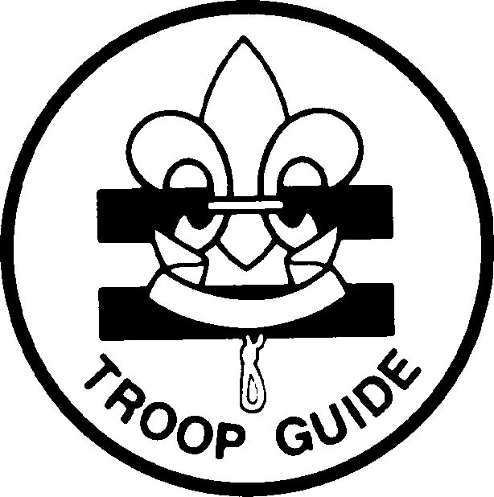
Troop Guide

Name: __________________________
Patrol: __________________________

Term: ___/___/____ to __/__/____

Job Description: The Troop Guide works with new Scouts. He helps them feel comfortable and earn their First Class rank.

Term Limits: A maximum of two six month terms (they may be consecutive)

Filled: Appointed by the Senior Patrol Leader with the advice and consent of the Scoutmaster.

Prerequisites: A scout must be of at least First Class rank

Leadership Position Coordinator: Assistant Scoutmaster of the new Scout patrol

Duties of Troop Guide:
1. Introduces new Scouts to troop operations.
2. Guides new Scouts through early Scouting activities
3. Helps new Scouts earn First Class in their first year.
4. Teaches basic Scout skills.
5. Coaches the patrol leader of the new Scout patrol on his duties.
6. Works with the patrol leader at Patrol Leaders' Council meetings.
7. Attends Patrol Leaders' Council meetings with the patrol leader of the new Scout patrol.
8. Enthusiastically wears the Scout uniform correctly
9. Lives by the Scout Oath and Law
10. Shows and helps develop Scout Spirit
11. Actively participate in outdoor activities

As Troop Guide, I ____________________ accept responsibility for these duties.
(sign and date)

As Parent of the Troop Guide, I agree with the commitment my son is making and promise to support him in his duties (training, troop meetings). _________________________
(sign and date)

As Assistant Scoutmaster, I _____________________ will assist you in carrying out your duties.
(sign and date)

-------------------------------------------------------------------------------------------------------------------------------------------------------------
Troop Guide Evaluation (at end of term):

Assistant Scoutmaster ______________________

Date/Initials
__________ Briefed on duties and responsibilities
__________ Present a written monthly report to the Patrol Leaders Council
__________ Reports on new scout advancement toward First Class rank
__________ Teaches basic Scout skills
__________ Coaches new scout patrol leader and assists him at the PLC meetings
__________ Attends 75% of PLC meetings Actual percentage _____
__________ Attends 55% of all Troop Meetings Actual percentage _____
__________ Attends 55% of all Troop outings Actual percentage _____

Retain this form on file for the Advancement Coordinator

Troop 161’s Leadership Card
Troop Quartermaster
Name: __________________________
Patrol: __________________________

Term: ___/___/____ to __/__/____

Job Description: Manages all the troop equipment

Term Limits: A maximum of two nonconsecutive six month terms

Filled: Appointed by the Senior Patrol Leader with the advice and consent of the Scoutmaster.

Prerequisites: 1. A Scout must be of at least First Class rank.
2. Quartermasters should be assigned from each patrol

Leadership Position Coordinator: Adult Quartermaster

Duties of Troop Quartermaster:
1. Keeps an inventory of troop equipment in Boy Scout Trailer
2. Submits monthly inventory report to the PLC & to Adult Quartermaster
3. Make sure equipment is in good working condition and assists Adult Quartermaster in repairs
4. Issues equipment to patrols/scouts/adults and makes sure it is returned in clean & good working condition
5. Makes suggestions to Adult Quartermaster/Troop Committee member for new or replacement items
6. Keeps equipment storage facilities neat & clean
7. Maintains a sign-out log for equipment used, and follows-up to ensure equipment is returned
8. Sets a good example
9. Wears the Scout uniform correctly
10. Lives by the Scout Oath and Law
11. Shows and helps develop Scout Spirit
12. Actively participates in outdoor activities

As Quartermaster, I ____________________ accept responsibility for these duties.
(sign and date)

As Parent of the Troop Quartermaster, I agree with the commitment my son is making and promise to support him in his duties (training, troop meetings). _________________________
(sign and date)

As Adult Quartermaster, I _____________________ will assist you in carrying out your duties.
(sign and date)

-------------------------------------------------------------------------------------------------------------------------------------------------------------
Quartermaster Evaluation (at end of term):

Adult Quartermaster ______________________

Date/Initials
__________ Briefed on duties and responsibilities
__________ Works with other troop quartermaster to prepare for an upcoming event and submits a plan to the Adult
Quartermaster A) enough dry goods for COH? check on food stuffs – out of date?, enough rope? etc.
B) fill propane tanks, enough charcoal & lighter fluid? enough garbage bags? etc.
__________ Maintain and assist in repair of troop equipment following each outing, as needed
__________ Verify the inventories with the new troop quartermaster the end of the term
__________ Issues equipment (loads and unloads) for each outing
__________ Present a written monthly report to the Patrol Leaders Council
__________ Attend 55% of troop outings Actual percentage _____
__________ Attend 75% of all Troop meetings Actual percentage _____

Retain this form on file for the Advancement Coordinator
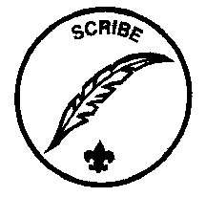
Troop 161’s Leadership Card
Scribe
Name: __________________________
Patrol: __________________________

Term: ___/___/____ to __/__/____

Job Description: The scribe keeps the troop records. He records the minutes of the Patrol Leaders’ Council and keeps a record of dues, advancement and Scout attendance at all troop meetings & activities.

Term Limits: A maximum of two nonconsecutive six month terms

Filled: Appointed by the Senior Patrol Leader with the advice and consent of the Scoutmaster.

Prerequisites: A Scout must be of at least First Class rank.

Leadership Position Coordinators: Treasurer, Advancement Coordinator

Duties of Troop Scribe:
1. Attends and records the minutes of the Patrol Leaders’ Council meetings
2. Records individual Scout attendance and helps secure payments of dues
3. Works with the Advancement Coordinator to record individual scout advancement
4. Works with the Treasurer/ASM for that activity to record activity payments
5. Keeps minutes of the Patrol Leaders’ Council
6. Handles correspondence appropriately
7. Sets a good example
8. Wears the Scout uniform correctly
9. Lives by the Scout Oath and Law
10. Shows and helps develop Scout Spirit
11. Actively participates in outdoor activities

As Scribe, I ____________________ accept responsibility for these duties.
(sign and date)

As Parent of the Scribe, I agree with the commitment my son is making and promise to support him in his duties (training, troop meetings). _________________________
(sign and date)

As Advancement Coordinator, I _____________________ will assist you in carrying out your duties.
(sign and date)

As Treasurer/ASM, I _____________________ will assist you in carrying out your duties.
(sign and date)
-------------------------------------------------------------------------------------------------------------------------------------------------------------
Scribe Evaluation (at end of term):

Advancement Chairman ______________________
Treasurer/ASM _________________________

Date/Initials
__________ Briefed on duties and responsibilities
__________ Ensure attendance sheets are collected at troop meetings and all activities
__________ Assist Scoutmaster during troop elections
__________ Takes minutes of the PLC meetings
__________ Works with Treasurer/ASM on activity payments
__________ Works with Advancement Coordinator on individual scout advancement
__________ Attend 75% of troop meetings Actual percentage _____
__________ Attend 55% of troop outings Actual percentage _____
__________ Attends 75% of patrol leader council meetings Actual percentage _____

Retain this form on file for the Advancement Coordinator
Troop 161’s Leadership Card
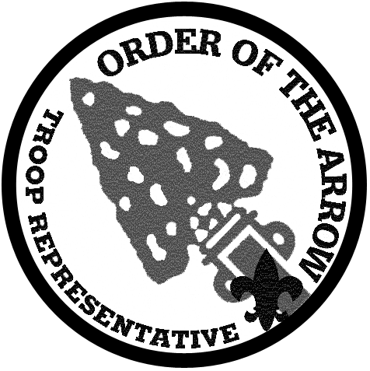
Order of the Arrow Troop Representative

Name: __________________________
Patrol: __________________________

Term: ___/___/____ to __/__/____

Job Description: The Order of the Arrow Troop Representative enhances the image of the Order of the Arrow by serving as a youth liaison between the troop and the local OA lodge and chapter (counts as position of responsibility).

Prerequisites: 1. Must be a member of the Order of the Arrow.
2. A Scout must have attained the rank of First Class

Filled: Appointed by the Senior Patrol Leader with the advice and consent of the Scoutmaster.

Term Limits: A maximum of two nonconsecutive six month terms.

Leadership Position Coordinator: Assistant Senior Patrol Leader

Duties of Order of the Arrow Representative:
1. Serves as a communication link between the lodge and chapter and the troop.
2. Encourages year-round and resident camping in the troop.
3. Encourages older-Scout participation in high-adventure programs.
4. Encourages Scouts to actively participate in community service projects.
5. Assists with leaders skills training in the troop.
6. Encourages Arrowmen to assume leadership positions in the troop.
7. Encourages Arrowmen in the troop to be active participants in lodge and/or chapter activities and to seal their membership in the Order by becoming Brotherhood members.
8. Sets a good example.
9. Wears the Scout uniform correctly.
10. Lives by the Scout Oath and Law, and OA Obligation
11. Shows and helps develop Scout Spirit
12. Actively participates in outdoor activities

As Order of the Arrow Troop Representative, I ____________________ accept responsibility for these duties.
(sign and date)

As Parent of the OA Representative, I agree with the commitment my son is making and promise to support him in his duties (training, troop meetings). _________________________
(sign and date)

As Assistant Scoutmaster and an OA member, I _____________________ will assist you in carrying out your duties.
(sign and date)
-------------------------------------------------------------------------------------------------------------------------------------------------------------
Order of the Arrow Troop Representative Evaluation (at end of term):

Assistant Scoutmaster ______________________

Date/Initials
__________ Briefed on duties and responsibilities
__________ Serves as a communication link between the lodge and chapter and the troop.
__________ Encourages Arrowmen to assume leadership positions in the troop
__________ Encourages Arrowmen to become Brotherhood members
__________ Encourages older-Scout participation in high-adventure programs
__________ Attends 55% of all Troop Meetings Actual percentage _____
__________ Attends 55% of all outings Actual percentage _____

Retain this form on file for the Advancement Coordinator
Troop 161’s Leadership Card
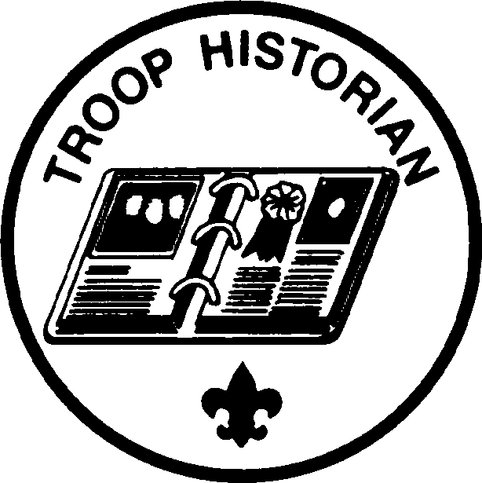
Historian
Name: __________________________
Patrol: __________________________

Term: ___/___/____ to __/__/____

Job Description: Troop Historian keeps an historical record and scrapbook of troop activities.

Prerequisites: A Scout must be of at least First Class rank.

Filled: Appointed by the Senior Patrol Leader with the advice and consent of the Scoutmaster.

Term Limits: A maximum of two nonconsecutive six month terms.

Leadership Position Coordinator: Assistant Scoutmaster

Duties of Historian:
1. Gathers pictures and facts about past troop activities and keeps them in historical file or scrapbook
2. Takes care of troop trophies, ribbons, and souvenirs of troop activities
3. Keeps information about former members and alumni of the troop
4. Sets a good example
5. Wears the Scout uniform correctly
6. Lives by the Scout Oath and Law
7. Shows and helps develop Scout Spirit
8. Actively participates in outdoor activities

As Historian, I ____________________ accept responsibility for these duties.
(sign and date)

As Parent of the Troop Historian, I agree with the commitment my son is making and promise to support him in his duties (training, troop meetings). _________________________
(sign and date)

As Assistant Scoutmaster, I _____________________ will assist you in carrying out your duties.
(sign and date)

-------------------------------------------------------------------------------------------------------------------------------------------------------------
Historian Evaluation (at end of term):

Assistant Scoutmaster ______________________

Date/Initials
__________ Briefed on duties and responsibilities
__________ Write a summary for each troop activity/outing including at least two paragraphs & four photos describing the
event (Include the attendance) These reports will then be forwarded to the Assistant Scoutmaster responsible for Publicity.
__________ Collect newspaper articles/pictures of troop activities
__________ Assemble outing summaries/articles/pictures into a scrapbook
__________ Presents a written monthly report to the Patrol Leaders Council
__________ Attends 75% of all Troop Meetings Actual percentage _____
__________ Attends 55% of all activities & outings Actual percentage _____

Retain this form on file for the Advancement Coordinator
Troop 161’s Leadership Card

Librarian
Name: __________________________
Patrol: __________________________

Term: ___/___/____ to __/__/____

Job Description: The librarian takes care of troop literature

Term Limits: A maximum of two nonconsecutive six month terms

Filled: Appointed by the Senior Patrol Leader with the advice and consent of the Scoutmaster.

Prerequisites: A Scout must be of at least First Class rank.

Leadership Position Coordinator: Committee Chairman

Duties of Troop Librarian:
1. Sets up and takes care of the troop library
2. Keeps records of books and pamphlets owned by the troop
3. Adds new or replacement items as needed
4. Keeps books and pamphlets; makes them available for borrowing at troop meetings
5. Keeps a system for checking books and pamphlets in and out
6. Follows up on late returns
7. Sets a good example
8. Wears the Scout uniform correctly
9. Lives by the Scout Oath and Law
10. Shows and helps develop Scout Spirit
11. Actively participates in outdoor activities

As Librarian, I ____________________ accept responsibility for these duties.
(sign and date)

As Parent of the Librarian, I agree with the commitment my son is making and promise to support him in his duties (training, troop meetings). _________________________
(sign and date)

As Committee Chairman, I _____________________ will assist you in carrying out your duties.
(sign and date)

-------------------------------------------------------------------------------------------------------------------------------------------------------------
Librarian Evaluation (at end of term):

Committee Chairman ______________________

Date/Initials
__________ Briefed on duties and responsibilities
__________ Bring the library all troop meetings
__________ Complete an accurate inventory of the troop library and have the list available at each troop meeting for
interested scouts. Make available the requested materials.
__________ Maintain a sign-out log for materials and follow-up to ensure material is returned
(post an overdue listing once a month at the troop meetings)
__________ Review the library at least once for out-of-date materials and discuss with the Committee Chairman items for
possible retirement from the library
__________ Present a written monthly report to the Patrol Leaders Council
__________ Attends 75% of troop meetings Actual percentage _____
__________ Attends 55% of all outings Actual percentage _____

Retain this form on file for the Advancement Coordinator
Troop 161’s Leadership Card
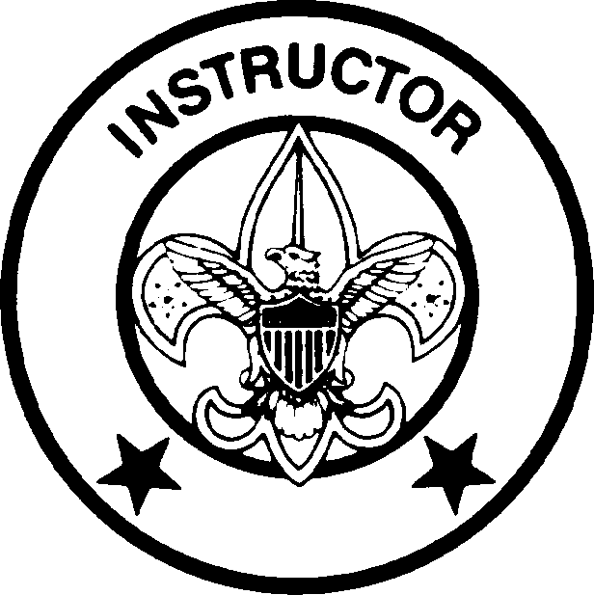
Instructor
Name: __________________________
Patrol: __________________________

Term: ___/___/____ to __/__/____

Job Description: The instructor works with scouts to help them learn skills for rank advancement and merit badge
requirements.

Prerequisites: 1. Required to have earned all the pertinent merit badges in his area of expertise.
2. A Scout must have attained the rank of Life or Eagle

Filled: Appointed by the Senior Patrol Leader with the advice and consent of the Scoutmaster.

Term Limits: None

Leadership Position Coordinator: Assistant Scoutmaster responsibly for Instruction

Duties of Instructor:
1. Required to have full knowledge of the information in the area of his expertise & is able to teach/demonstrate his knowledge
whenever called upon
2. Prepares well in advance for each teaching assignment and reviews the specific skills to be taught with his Leader Instructor prior to the meeting, outing or activity
3. Sets a good example
4. Wears the Scout uniform correctly
5. Lives by the Scout Oath and Law
6. Shows and helps develop Scout Spirit
7. Actively participates in outdoor activities

Instructor types:
1. Camping & Hiking 4. Fire building 7. Orienteering
2. Canoeing 5. First Aid 8. “Special Project” (as assigned by the SM)
3. Cooking 6. Knots & Lashing

As Instructor, I ____________________ accept responsibility for these duties.
(sign and date)

As Parent of the Instructor, I agree with the commitment my son is making and promise to support him in his duties (training, troop meetings). _________________________
(sign and date)

As Assistant Scoutmaster, I _____________________ will assist you in carrying out your duties.
(sign and date)

-------------------------------------------------------------------------------------------------------------------------------------------------------------
Instructor Evaluation (at end of term):

Assistant Scoutmaster ______________________

Date/Initials
__________ Briefed on duties and responsibilities
__________ Conduct at least three classes resulting in requirements being signed off in assigned specialty
__________ Perform at least one demonstration during a troop meeting/ outing (except Special Project)
__________ Special Projects – Completes project (agreed upon at its conception with SM)
__________ Attends 55% of all Troop Meetings Actual percentage _____
__________ Attends 55% of all outings Actual percentage _____

Retain this form on file for the Advancement Coordinator
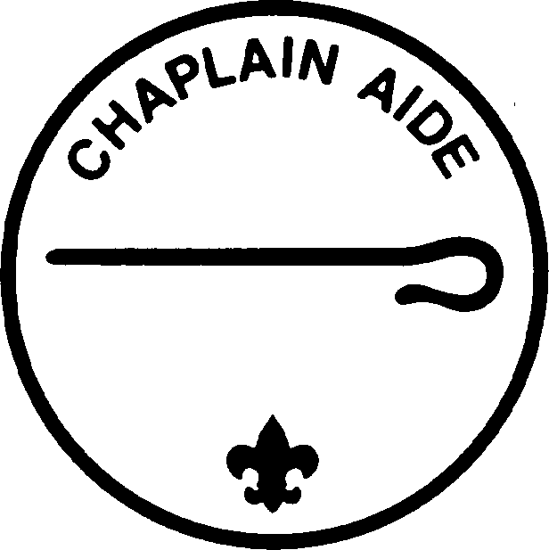
Troop 161’s Leadership Card
Chaplain Aide
Name: __________________________
Patrol: __________________________

Term: ___/___/____ to __/__/____

Job Description: The Chaplain Aide works with the Troop Chaplain (ASM) to meet the religious needs of Scouts in the troop. He also works to promote the religious emblem’s program.

Prerequisites: A scout must be of at least First Class rank

Filled: Appointed by the Senior Patrol Leader with the advice and consent of the Scoutmaster.

Term Limits: A maximum of two nonconsecutive six month terms.

Leadership Position Coordinator: Troop Chaplain

Duties of Chaplain Aide:
1. Assists the Troop Chaplain with religious services at troop activities
2. Informs scouts about the religious emblem program for their faith
3. Records each scout’s award and reports dates to the Advancement Coordinator.
4. Makes sure religious holidays are considered during troop program planning
5. Responsible for leading troop meeting and conducting services on each outing.
6. Sets a good example
7. Wears the Scout uniform correctly
8. Lives by the Scout Oath and Law
9. Shows and helps develop Scout Spirit
10. Actively participates in outdoor activities.

As Chaplain Aide, I ____________________ accept responsibility for these duties.
(sign and date)

As Parent of the Chaplain Aide, I agree with the commitment my son is making and promise to support him in his duties (training, troop meetings). _________________________
(sign and date)

As Assistant Scoutmaster, I _____________________ will assist you in carrying out your duties.
(sign and date)

-------------------------------------------------------------------------------------------------------------------------------------------------------------
Chaplain Aide Evaluation (at end of term):

Troop Chaplain/ASM ______________________

Date/Initials
__________ Briefed on duties and responsibilities
__________ Coordinate with other chaplain’s aides and conduct at least two religious ceremonies at troop outings
__________ Complete a typewritten program for use at a troop religious service
__________ Presents a written monthly report to the Patrol Leaders Council
__________ Attend 75% of all Troop Meetings Actual percentage _____
__________ Attend 55% of all troop outings Actual percentage _____

.

Retain this form on file for the Advancement Coordinator
Troop 161’s Leadership Card

Den Chief

Name: __________________________
Patrol: __________________________

Term: ___/___/____ to __/__/____

Job Description: The Den Chief works with Cub Scouts, Webelos Scouts and Den Leaders in the Cub Scout pack.

Term Limits: A maximum of two six month terms (they may be consecutive)

Filled: Appointed by the Senior Patrol Leader with the advice and consent of the Scoutmaster.

Prerequisites: A scout must be of at least First Class rank

Leadership Position Coordinator: The Den Leader in the pack and the Cub Scout Liaison

Duties of Den Chief:
1. Serve as activities assistant at den meetings
2. Meet regularly with Den Leader to review den and pack meeting plans
3. Helps prepare boys to join Boy Scouting
4. Helps out at monthly pack meetings
5. Meets with adult members of the den, pack, and troop as necessary
6. Projects a positive image of Boy Scouting
7. Sets a good example
8. Wears the Scout uniform correctly
9. Lives by the Scout Oath and Law
10. Shows and helps develop Scout Spirit
11. Actively participate in outdoor activities

As Den Chief, I ____________________ accept responsibility for these duties.
(sign and date)

As Parent of the Den Chief, I agree with the commitment my son is making and promise to support him in his duties (training, troop meetings). _________________________
(sign and date)

As Den Leader, I _____________________ will assist you in carrying out your duties.
(sign and date)

As Assistant Scoutmaster, I will assist you in carrying out your duties. ___________________
(sign and date)
-------------------------------------------------------------------------------------------------------------------------------------------------------------
Den Chief Evaluation (at end of term):

Den Leader ______________________ Assistant Scoutmaster ___________________

Date/Initials
__________ Briefed on duties and responsibilities
__________ Provides assigned Den information and Den leader’s name to the ASPL immediately upon assuming position
__________ Attends 65% of Den Meetings verified by Den Leader Actual percentage _____
__________ Attends 65% of all Pack Meetings verified by Den Leader Actual percentage _____
__________ Assists assigned Cub Scouts with advancement of at least one rank
__________ Obtains written evaluation on your performance from assigned Den leader
__________ Presents a written monthly report to the Patrol Leaders Council
__________ Attends 55% of all Troop Meetings Actual percentage _____
__________ Attends 55% of all Troop outings Actual percentage _____

Retain this form on file for the Advancement Coordinator
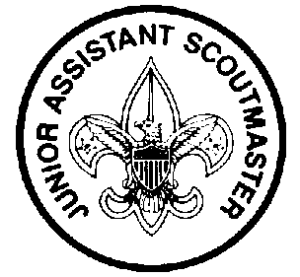
Troop 161’s Leadership Card
Junior Assistant Scoutmaster
Name: __________________________
Patrol: __________________________

Term: ___/___/____ to __/__/____

Job Description: The junior assistant Scoutmaster serves in the capacity of an assistant Scoutmaster except where legal age and maturity are required. He must be at least 16 years old and not yet 18 years of age. He is appointed because of his leadership ability.

Prerequisites: A Scout must be at least 16 years old and have attained the rank of Life or Eagle Scout.

Term Limits: None

Filled: Appointed by the Senior Patrol Leader with the advice and consent of the Scoutmaster.

Leadership Position Coordinator: Scoutmaster

Duties of a Junior Assistant Scoutmaster:
1. Functions as an Assistant Scoutmaster
2. Accomplishes any duties assigned by the Scoutmaster
3. Sets a good example
4. Wears the Scout uniform correctly
5. Lives by the Scout Oath and Law
6. Shows and helps develop Scout Spirit

As Junior Assistant Scoutmaster, I accept responsibility for these duties. ________________________
(sign and date)

As Parent of the Junior Assistant Scoutmaster, I agree with the commitment my son is making and promise to support him in his duties (training, troop meetings). _________________________
(sign and date)

As Scoutmaster, I _____________________ will assist you in carrying out your duties.
(sign and date)

-------------------------------------------------------------------------------------------------------------------------------------------------------------
Junior Assistant Scoutmaster (at end of term):

Scoutmaster ______________________

Date/Initials
__________ Briefed on duties and responsibilities
__________ Attend at least three outings and help lead the organization of evening programs
__________ Become aware of the advancement status of first year scouts and teach scout skills
__________ Volunteer to participate in Tenderfoot, Second Class, and First Class boards of review
__________ Attend 75 % of all Troop Meetings Actual percentage ______
__________ Attend 75% of all Executive Committee Meetings Actual percentage ______
__________ Attend 55% of all outings/activities Actual percentage ______

Retain this form on file for the Advancement Coordinator
Troop 161’s Leadership Card
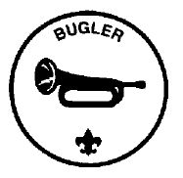
Troop Bugler

Name: __________________________
Patrol: __________________________

Term: ___/___/____ to __/__/____

Job Description: The Troop Bugler plays for the troop on campouts and other appropriate functions.

Prerequisites: 1. A Scout must have attained the rank of First Class.
2. Proficiency in music.

Restrictions: THIS POSITION COUNTS FOR STAR AND LIFE RANK ADVANCEMENT ONLY.

Filled: Appointed by the Senior Patrol Leader with the advice and consent of the Scoutmaster.

Term Limits: A maximum of two consecutive or nonconsecutive six month terms.

Leadership Position Coordinator: Scoutmaster

Duties of the Bugler:
1. Learns to play Reveille, Taps, Retreat, To the Color, and other appropriate patriotic songs
2. Works with the Scoutmaster to determine appropriate songs for each campout
3. Calls Troop to order at campouts when present
4. Sets a good example
5. Enthusiastically wears the Scout uniform correctly
6. Lives by the Scout Oath and Law
7. Shows and helps develop Scout Spirit
8. Actively participates in outdoor activities

As Bugler, I ____________________ accept responsibility for these duties.
(sign and date)

As Parent of the Bugler, I agree with the commitment my son is making and promise to support him in his duties (training, troop meetings). _________________________
(sign and date)

As Assistant Scoutmaster, I _____________________ will assist you in carrying out your duties.
(sign and date)

-------------------------------------------------------------------------------------------------------------------------------------------------------------
Bugler Evaluation (at end of term):

Assistant Scoutmaster ______________________

Date/Initials
__________ Briefed on duties and responsibilities
__________ Learned Reveille, Taps, Retreat, To the Color and other appropriate patriotic songs.
__________ Calls Troops to order at campout when needed
__________ Attends 55% of all Troop Meetings Actual percentage _____
__________ Attends 55% of all outings Actual percentage _____

Retain this form on file for the Advancement Coordinator
Troop 161’s Leadership Card
Junior Assistant Scoutmaster
Name: __________________________
Patrol: __________________________

Term: ___/___/____ to __/__/____

Job Description: The Junior Assistant Scoutmaster serves in the capacity of an assistant Scoutmaster except where legal age and maturity are required. He must be at least 16 years old and not yet 18 years of age. He is appointed because of his leadership ability.

Prerequisites: A Scout must be at least 16 years old and have attained the rank of Life or Eagle Scout.

Term Limits: None

Filled: Appointed by the Senior Patrol Leader with the advice and consent of the Scoutmaster.

Leadership Position Coordinator: Scoutmaster

Duties of a Junior Assistant Scoutmaster:
1. Functions as an Assistant Scoutmaster
2. Accomplishes any duties assigned by the Scoutmaster
3. Sets a good example
4. Wears the Scout uniform correctly
5. Lives by the Scout Oath and Law
6. Shows and helps develop Scout Spirit

As Junior Assistant Scoutmaster, I accept responsibility for these duties. ________________________
(sign and date)

As Parent of the Junior Assistant Scoutmaster, I agree with the commitment my son is making and promise to support him in his duties (training, troop meetings). _________________________
(sign and date)

As Scoutmaster, I _____________________ will assist you in carrying out your duties.
(sign and date)

-------------------------------------------------------------------------------------------------------------------------------------------------------------
Junior Assistant Scoutmaster (at end of term):

Scoutmaster ______________________

Date/Initials
__________ Briefed on duties and responsibilities
__________ Attend at least three outings and help lead the organization of evening programs
__________ Become aware of the advancement status of first year scouts and teach scout skills
__________ Volunteer to participate in Tenderfoot, Second Class, and First Class boards of review
__________ Attend 75 % of all Troop Meetings Actual percentage ______
__________ Attend 75% of all Executive Committee Meetings Actual percentage ______
__________ Attend 55% of all outings/activities Actual percentage ______

Retain this form on file for the Advancement Coordinator
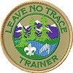
Troop 161’s Leadership Card
Leave No Trace Trainer
Name: __________________________
Patrol: __________________________

Term: ___/___/____ to __/__/____

Job Description: The Leave No Trace Trainer specializes in teaching Leave No Trace principles and ensuring that the troop follows these principles on outings. He can also help Scouts earn the Leave No Trace award.

Prerequisites: 1. A Scout must have attained the rank of First Class.
2. A Scout must have completed Leave No Trace training and earned the Camping and Environmental Science merit badges.

Term Limits: None

Filled: Appointed by the Senior Patrol Leader with the advice and consent of the Scoutmaster.

Leadership Position Coordinator: Scoutmaster

Duties of a Leave No Trace Trainer:
1. Teaches Leave No Trace principles to Scouts
2. Have a thorough understanding of and commitment to Leave No Trace
3. Ensures that the troop follows these principles on outings
4. Sets a good example
5. Wears the Scout uniform correctly
6. Lives by the Scout Oath and Law
7. Shows and helps develop Scout Spirit

As a Leave No Trace Trainer, I accept responsibility for these duties. ________________________
(sign and date)

As Parent of the Leave No Trace Trainer, I agree with the commitment my son is making and promise to support him in his duties (training, troop meetings). _________________________
(sign and date)

As Scoutmaster, I _____________________ will assist you in carrying out your duties.
(sign and date)

-------------------------------------------------------------------------------------------------------------------------------------------------------------
Leave No Trace Trainer (at end of term):

Scoutmaster ______________________

Date/Initials
__________ Briefed on duties and responsibilities
__________ Attend at least three outings and help lead the organization of evening programs
__________ Become aware of the advancement status of first year scouts and teach scout skills
__________ Volunteer to participate in Tenderfoot, Second Class, and First Class boards of review
__________ Attend 75 % of all Troop Meetings Actual percentage ______
__________ Attend 55% of all outings/activities Actual percentage ______

Retain this form on file for the Advancement Coordinator
Troop 161’s Leadership Card

Webmaster
Name: __________________________
Patrol: __________________________

Term: ___/___/____ to __/__/____

Job Description: The troop webmaster is responsible for maintaining the troop’s website.

Prerequisites: A Scout should have basic computer literacy and knowledge of programs for posting web content on the Troop’s website.

Term Limits: None

Filled: Appointed by the Senior Patrol Leader with the advice and consent of the Scoutmaster.

Leadership Position Coordinator: Scoutmaster

Duties of a Webmaster:
1. Collects photos or stories about the Troop from Adults or Scouts
2. Works with the Committee Chairman to update information on the Troop website monthly
3. Works with the Committee Chairman on improving the Troop website while maintaining Scout privacy rules
4. Sets a good example
5. Wears the Scout uniform correctly
6. Lives by the Scout Oath and Law
7. Shows and helps develop Scout Spirit

As Webmaster, I accept responsibility for these duties. ________________________
(sign and date)

As Parent of the Webmaster, I agree with the commitment my son is making and promise to support him in his duties (training, troop meetings). _________________________
(sign and date)

As Committee Chairman, I _____________________ will assist you in carrying out your duties.
(sign and date)

-------------------------------------------------------------------------------------------------------------------------------------------------------------
Webmaster (at end of term):

Scoutmaster ______________________

Date/Initials
__________ Briefed on duties and responsibilities
__________ Attend at least three outings and help lead the organization of evening programs
__________ Become aware of the advancement status of first year scouts and teach scout skills
__________ Volunteer to participate in Tenderfoot, Second Class, and First Class boards of review
__________ Attend 75 % of all Troop Meetings Actual percentage ______
__________ Attend 55% of all outings/activities Actual percentage ______

Retain this form on file for the Advancement Coordinator
TROOP 161 ORGANIZATION CHART
SCOUTMASTER
ASST SCOUTMASTER
ASST SCOUTMASTER
ASST SCOUTMASTER
ASST SCOUTMASTER
NEW PATROL
SENIOR PATROL LEADER
JUNIOR ASST SCOUTMASTER
ASST SENIOR PATROL LEADER
PATROL LEADER
PATROL LEADER
PATROL LEADER
ASST PATROL LEADER
ASST PATROL LEADER
ASST PATROL LEADER
OA TROOP
REP
QUARTER-
MASTER
LIBRARIAN
CHAPLAIN AIDE
INSTRUCTOR
SCRIBE
LEAVE NO TRACE TRAINER
BUGLER
WEBMASTER
HISTORIAN
TROOP
GUIDE
NEW SCOUT PATROL LEADER
DEN
CHIEF
NEW SCOUT ASST PATROL LEADER

PLC MEMBERS – SPL, ASPL, PATROL LEADERS, TROOP GUIDE, SCRIBE

SCRIBE – non-voting member of the PLC

ASS’T PATROL LEADERS ATTEND PLC IF PATROL LEADERS UNAVAILABLE

OA TROOP REPRESENTATIVE – Provides written reports monthly to SPL or PLC

